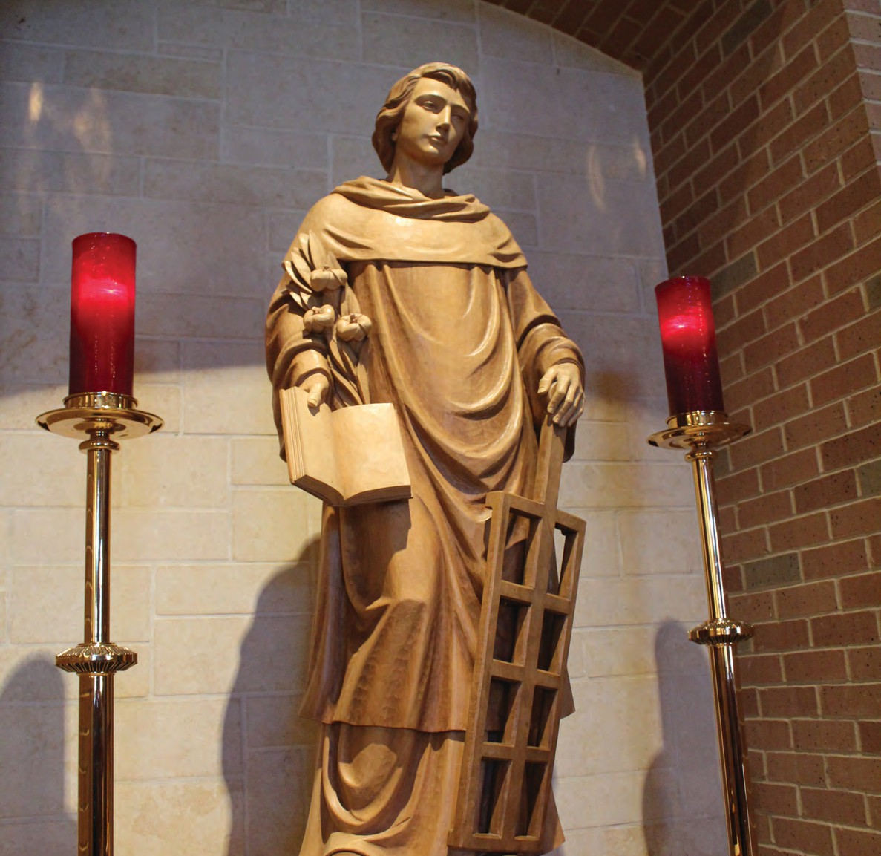









AUGUST
2025

MINISTRY LEADERSHIP
HANDBOOK

3100 Sweetwater Blvd. | Sugar Land, Texas 77479 | 281-980-9812 |www.stlaurence.org




WHO WE ARE
We the people of St. Laurence Catholic Church are centered in the love of Christ and live to glorify God in all we do.

At St. Laurence Catholic Church, we respond to Jesus who calls us to love God and our neighbor. As a member of this faith community, I strive to:
LOVE by showing respect, mercy and compassion to all
CONNECT with others in a meaningful way
GROW closer to God through prayer, Sunday Mass and the Sacraments
LEARN about my Faith and share it with others

Filled with the Holy Spirit, I will be a grateful and supportive member of the Body of Christ.

St. Laurence Catholic Church

MINISTRY SUPPORT
Thank you for stewarding and leading a ministry of St. Laurence Catholic Church!
As a ministry leader, you are sharing your unique talents, skills, knowledge and inspiration with this ministry. In this way, you are truly a steward – caring for this essential ministry – and nurturing its growth and the spiritual growth of its members.
You’re not doing this alone. Remember, this is God’s ministry, so let the Holy Spirit guide you in all you do. Additionally, you have a large Parish Staff and wonderful clergy, plus a liaison from the Discipleship Council eager to help, so use your resources!

ST. LAURENCE CLERGY
Fr. Reginald Samuels (rsamuels@stlaurence.org)
Fr. Wayne Ly (wly@stlaurence.org)
Dcn. Rey Arellano (deacon.rey@stlaurence.org)
Dcn. Roger Boneno (rboneno@stlaurence.org)
Dcn. Don Burns (don@donburns.com)
Dcn. Tim Cullen (tcullen@stlaurence.org)
Dcn. Dennis Henderson (dhenderson@stlaurence.org)
Dcn. Patrick Kinnick (pkinnick@stlaurence.org)
Dcn. Charles Plant (DeaconCharles@outlook.com) Dcn. Tom Ruck (truck@stlaurence.org)

STAFF RESOURCES FOR MINISTRIES
Financial & legal approval; security; approval for fundraising/special events
Suzanne Byrne | Parish Administrator (sbyrne@stlaurence.org)

Monetary receipts & deposits; reimbursements; payments Pat Martin | Parish Bookkeeper (pmartin@stlaurence.org) Ann Candea | Accounts Receivable (acandea@stlaurence.org)
Ministry support, promotion, communications
Belinda Maldonado | Director of Parish Life (bmaldonado@stlaurence.org) Jason Garcia | Director of Communications (jgarcia@stlaurence.org)
Facilities, room reservations, maintenance, audio-visual Sheila Stulak | Facilities Director (sstulak@stlaurence.org) Nia Sepe | Facilities Scheduler (nsepe@stlaurence.org)
Bryan Bilocura | AV & IT Specialist (bbilocura@stlaurence.org)

Liturgies, Mass and other events in the church
Betty Holub | Liturgy Coordinator (bholub@stlaurence.org)

Service projects, special drives, charitable donations
Pennie DeGroot | Social Concerns Director (pdegroot@stlaurence.org)

DISCIPLESHIP COUNCIL MINISTRY LIAISONS

Ruben Alvarez ralvarez05@comcast.net
Legion of Mary
Re-Membering Church
St. Laurence Singles

Roxie Casal
roczi33@yahoo.com
Hearts of Jesus & Mary
New Evangelization
Raise a Hallelujah Prayer Group

Michelle Cashiola mcashiola@gmail.com
J.O.Y. Club
Tuesday Morning Bible Study
Vocations Committee
Youth Ministry

Katie Coppedge coppedges@att.net
ACTS Retreats
Liturgical Ministries, Altar Linen, Sponsor Couples
Medical Missionaries
SD, Annulments, Marian Consecration

Mark Coppedge mark.coppedge@att.net Cub Scout Pack 1828 Divine Mercy
DivorceCare

Joy Eckelkamp
jle824@yahoo.com
Altar Servers
Bazaar
SLCS
Greeters

Jeff Ellard
jte64@comcast.net
Cancer Support
Christian Meditation & Contemplative Prayer
Music Ministry

Madeleine Ellard
akamadge@comcast.net
Adoration
Caregivers Support
Ladies Guild/Funerals/Meals that Heal
Lay Apostle Prayer

JD Gutierrez gutijoed3371@aol.com
Catholic Daughters
Knights of Columbus
Men’s Bible Studies
That Man Is You

Sylvia Gutierrez sgutierrez@stlaurence.org
Learn English Ministry
Loving Seniors
Social Concerns

Jerry Lo
jerryilo@gmail.com
Welcoming Ministry
Family Faith & Family Ministry
Habitat for Humanity

Linda Lo
Le_hl_99@yahoo.com
Mons & Tots
Natural Family Planning
Vietnamese Community

Stella Naik stellanaik@hotmail.com
Indian Subcontinent Ministry
Pastoral Care to the Sick & Homebound
St. Anthony of Padua Prayer Group

Jenny Nutzman jennynutzman@gmail.com
African Catholic Community
Bereavement Support
Challenge Club

Travis Nutzman
travisnutzman@gmail.com
AFF/RCIA/Marriage Enrichment/Connect
BSA Troop 818G & 828B
NAMI

Jojo Peters
petersjojo@yahoo.com
Baptism
Correctional Ministries
Learn Spanish Ministry

Alaina Short
alainamaryshort@gmail.com
Council of Catholic Women
PreK Faith Formation & Parish Library
Women of the Cloth

Zach Short
ztshort92@gmail.com
Art & Environment
Financial Peace University
Young Adults

Maciej Sypniewski
msypniewski@stlaurence.org
Catholic Men Called To Be Saints
Hispanic Ministry & Spanish Bible Study
Ushers

Edward Young dad22greatkids@gmail.com
Children’s Faith Formation
Filipino Community
Respect Life
Weekday Children's Program

ST. LAURENCE PASTORAL COUNCIL
Jessica Barry | jessica@thebarrybunch.us Shannon Brown | ufalum93@gmail.com Johana Camelo | jcamelo21@yahoo.com Jennifer Dye | jenn_dye@hotmail.com
Paul Fontenot | paul.s.fontenot@gmail.com Jim Grover | jimgrover@ventanaland.com
Phung Ngo-Burns | pb92902@yahoo.com
Al Sander | allan.sander@sbcglobal.net
Bill Woodard | bwoodard506@msn.com

WEB ADDRESS:
https://www.stlaurence.org/

MAILING ADDRESS:
St. Laurence Catholic Church 3100 Sweetwater Blvd.
Sugar Land, TX 77479

PHONE:
Parish Office: 281-980-9812
Ave Maria Center: 281-265-5774
St. Laurence Catholic School: 281-980-0500 Weekday Children’s Program: 281-313-0329


COMMUNICATIONS
TOP 10 stlaurence.org/parish-communications

Start with your page on the parish website. Every other media points there, so keep it fresh, informative, inviting and up to date.
1

Your ministry is part of our parish family. Be sure your communications reflect the mission, standards and teachings of the Catholic Church and St. Laurence Parish.
2

Communication should be a priority for all ministry leaders. A ministry cannot survive without effective communication and regular invitation to potential members.
3

Create a Flocknote group for your ministry. This is an efficient and effective way to communicate within your ministry – plus it connects your members to the parish.
4

Be timely. Contact Jason and Belinda to strategize your promotion plan well in advance of the event and submit articles/announcements/photos before the submission deadlines.
5


6 Be accurate. Proofread your submissions before sending.
7
For special design services, submit your request with 1) plenty of lead time, 2) finalized copy, and 3) clear instructions/expectations for the design concept.
8 Know your audience and communicate your message from their point of view.
9 There are many communication methods available to your ministry – use them!
10
We are here to assist you in promoting your events and activities, but remember, in parish ministry personal invitation is your most effective communication tool.

St. Laurence Catholic Church

PARISH COMMUNICATION TOOLS

DIRECTOR OF PARISH LIFE: Belinda Maldonado 281-980-9812 bmaldonado@stlaurence.org

DIRECTOR OF COMMUNICATIONS: Jason Garcia 281-980-9812 jgarcia@stlaurence.org

Your most EFFECTIVE communication tool is personal invitation. Any of the following communication channels may be EFFICIENT vehicles to assist you in promoting events, activities, meetings and attracting new members:
PARISH WEBSITE
- Parish ministries/groups are responsible for refreshing and keeping their own web page up to date
- This is the first and most important place to put news, all other media points to website for info
- Contact Jason Garcia for assistance in managing your web page
SUNDAY BULLETIN
- Submissions are due to Jason & Belinda 12 days in advance of Sunday you want it to appear
- Bulletin covers are reserved through Jason/Belinda at least 2 months in advance
- Full page flyers or long articles are reserved through Jason/Belinda at least a month in advance
FLOCKNOTE
- A parishwide Flocknote is sent each Wednesday to over 13,000 people
- Submissions are due to Jason & Belinda 2-3 days in advance
- Contact Jason to set up a Flocknote group for your ministry
SOCIAL MEDIA
- Submit requests and photos to Jason for posts & events on parish Facebook, Twitter and Instagram
BANNERS & DIGITAL DISPLAYS
- Digital displays around campus are updated weekly; contact Jason to promote your activity on screen
- Retractable banners for narthex and AMC must be approved by Belinda
- Contact Jason for specs and printer recommendations to create the banner
FLYERS & TRI-FOLD BROCHURES
- 8½x11 flyers and tri-fold brochures
- Space is usually available; advise Belinda that you’ve got a flyer to put there
MINSTRY HIGHLIGHT
- One ministry highlighted on Sundays; contact Belinda to schedule your ministry
- Ministry representatives distribute info and answer questions at Hospitality Desk after each Mass
TABLES ON THE PLAZA
- Open to parish ministries and Catholic schools/organizations; limit 2 groups on plaza per Sunday
- Reserve with FUR through Nia Sepe (nsepe@stlaurence.org) at least 1-2 months in advance
MASS ANNOUNCEMENTS
- Brief announcement of most essential news offered at the end of Mass
- Submit requests to Jason one week in advance
LAY WITNESS TALKS
- Lay speakers share their testimonies and invite parishioners to join them in their ministry
- Brief (3 minute) testimonials toward the end of Mass
- Contact Belinda to request this; upcoming year is scheduled in November
CREATIVE SERVICES
- We can assist you with content and creative development; please allow lead time for these projects


USE OF FACILITIES
TOP 10 stlaurence.org/ministry-resources

St. Laurence is your parish home, built and furnished with money contributed by you and your fellow parishioners – please treat your campus and facilities as you would your own home.
1

We recognize that not all ministries have members physically able to setup tables and chairs, but for those who can, it’s a great help when ministries offer to do their own setup.
2

Please end ministry meetings in a timely manner, either adhering to campus closing hours or being thoughtful of the next group scheduled in that room.
3

- Please leave the room better than you found it; wipe off tables and chairs.
- Collect all leftover meeting materials and dispose of trash.

6
7
8
9
10
Immediately notify a staff member on duty if anything in the room is broken or damaged.
If you notice a hazard anywhere on campus, please eliminate or report it to someone on staff.

If feasible (and necessary), please stack chairs and/or tables after your meeting.

If you have adjusted the thermostat for the AC, please return the temperature to 73 degrees.

Sound carries, please be mindful of others meeting nearby.

FACILITIES SCHEDULING
TOP 10 stlaurence.org/facilities-use-guidelines

Need to reserve a room/space on campus? Submit a FUR (Facilities Use Request) form via email to Nia Sepe (nsepe@stlaurence.org).
1

When is the campus available? The church office closes at 6pm Mon-Thurs and 4pm Friday. The entire campus closes at 9pm Monday-Thursday and at 4pm Friday.
2

Can we meet when the campus is closed? Please refer to the Yearly Church Closure Calendar; no meetings are scheduled on those dates.
3

Need assistance from our maintenance staff to do your room setup? Include specific and clear details on the FUR when you submit it.
4

Need to make a change to the FUR you submitted? Please submit a new FUR, no less than 24 hours before the event.
5

Need to cancel your scheduled event? Please notify Nia Sepe 24 hours in advance (or by noon Thursday for weekend events).
6

Need access to a/v equipment? There is a spot on the FUR to indicate if you require AV assistance, use of a microphone, projector, DVD player or if you plan to bring your laptop.
7

How do I know my event is scheduled? You will receive a confirmation email from Nia Sepe when the room is scheduled; please do not publicize your event until you have received and reviewed the confirmation.
8

Can anyone from my ministry submit a FUR? Each ministry should have only one representative responsible for scheduling facilities (usually the ministry leader). Some ministries work directly with Nia Sepe; some work through a liaison on staff.
9

Can we use a room without submitting a FUR, if it’s available? No. A FUR is more than just a room reservation; it impacts the schedule for A/C, receptionists, maintenance staff, and security. Also, a room may look available, but another group might be scheduled there within the hour.
10

St. Laurence Catholic Church - Facilities Use Request Form (FUR)

Instructions: Complete form and Email to: nsepe@stlaurence.org , fax to (281) 980-0686 or deliver to Parish Office. You will receive confirmation via e-mail that your request has been accepted, denied, or modified.
Please do not publicize your event until you have received confirmation.
Today’s Date: |  | New Request  Change Request* Delete Event |  | *IF CHANGE REQUEST:  Original Date  Original Location |  |  | Original Time
Ministry/Organization Name: |  |  |  | Circle Event Day(s):  Sun. Mon. Tues. Wed. Thurs. Fri. Sat.
Event Name: |  |  |  | Event Date(s):
Ministry/Org. Contact Name:
Ministry/Org. Contact Email Address: |  |  |  | Actual Event Time  From: To:
Home Phone: | Cell Phone: |  | Staff Phone Ext: | Additional minutes needed:  Setup: (mins.) Cleanup: (mins.)
Cancelations, changes, additions must be submitted  24 hours in advance of event  (by noon on Thursday preceding event for the weekend) |  |  |  | How many people expected to attend? |  |  | Is alcohol being served at this event?  Yes No
Preferred Room(s): Enter number below by order of preference of each room to be considered
COURTYARD COMPLEX |  |  | AVE MARIA PARISH LIFE CENTER |  | CHAPEL
Church  Church Plaza  Corpus Christi Room (Occ. 25)  Parish Hall (Occ. 250)  Parish Hall Kitchen  Other: |  |  | Guardian Angels Hall (Occ. 200)  Kitchen  Marian Hall A (Occ. 200)  Marian Hall B (Occ. 150)  Marian Hall A&B (Occ. 500)  Oratory of the Rosary (Occ. 46)  St. Anne Meeting Room (Occ. 15)  St. Clare Meeting Room (Occ. 40)  St. Francis Meeting Room (Occ. 45)  St. Joseph Meeting Room (Occ. 30)  Youth Hall (Occ. 170)  Classrooms 200/202 Combo (Occ. 48)  Classrooms 206/208 Combo (Occ. 48)  Classrooms (200 thru 214) (Occ. 24)  List: |  | Divine Mercy Chapel
 |  |  |  |  |  | SCHOOL
School Dining Hall
School Gym
 |  |  |  |  |  | SCHOOL USE ONLY
Conference Rm 1 (1st floor)
Conference Rm 2 (2nd floor)
School Library
School Classrooms (list)

ECC Classrooms (list)

Other:
**SETUP – All ministries and groups are strongly encouraged to perform their own setup. Groups of 20 or less are required to
perform their own setup. If you need maintenance staff assistance with your event a setup must be detailed in the box below at the time this form is submitted. If no setup is detailed, it is assumed no setup will be necessary and none will be provided.
Check one: We will perform our own setup. We need help with our setup described below.
**Setup details and/or diagram:
OTHER NEEDS: Check all that apply
Tables - # Rectangular # Round  Chairs - #  Oven/stove to heat food Refrigerator/Freezer space  Coffee set up (Not available for groups of less than 20) Regular coffee # of cups Decaf coffee # of cups  Disposable supplies-contact office for more information |  |  |  | Tech Help Needed? Yes / No  Microphone  Projector/TV for  DVD player (ours)  laptop (yours, HDMI or VGA required)

All rooms are assigned in accordance with the use policies set forth by St. Laurence Catholic Church.

Revised 8/3/2023


AUDIO-VISUAL
TOP 10 stlaurence.org/av

- DO watch your venue’s one-minute videos at https://av.stlaurence.org
- DO NOT unplug equipment that is already plugged in or factory reset them.
- DO give us your AV requests 3+ weeks in advance.
- DO NOT put stickers on screens or touch them with your fingers.
- DO notify staff about equipment or cables that appear to be malfunctioning.
- DO NOT factory reset equipment.


7
8
9
10
DO bring your own adapter if your laptop or tablet doesn’t have an HDMI video port.
DO NOT plow into protruding connectors when moving furniture.

DO start replacing your old VGA laptops with those that have the newer HDMI video connection.

DO NOT assume we can accommodate large or unusual requests.
Bonus: DO get someone on your team who is tech savvy!

BUSINESS OFFICE
TOP 10 pat@stlaurence.org

- Turn in all receipts in a timely manner (the next day).
- Never pay Sales Tax.
- Write legibly and sign your name when completing a Check Request Form.
4
Code everything when completing a Check Request Form:
  - Date received
  - Department or Ministry
  - Purpose or description
  - Date of event
  - Account coding & Project Code (if applicable)
  - Total amount
  - Purchaser name
  - Approval from supervisor

Do not email Check Request Forms or credit card receipts. Always submit original hardcopy forms, receipts, invoices, etc.
5

6 Please allow 8 work days for Check Requests to be fulfilled.
7
Notify the Business Office in advance of special events regarding large expenses and cash collections.

Coordinate any cash transactions (collections, donations, program fees, tips) with business office 2 weeks in advance of an event.
8

NEVER, EVER take home or store in an office desk cash/check collected from fundraisers or programs. Always deposit with Pat Martin or Ann Candea (Parish Business Office) or with Ruba Kaiser (Ave Maria Center) or make arrangements in advance for after-hours deposits.
9

Do not pre-pay for any goods or services; this is the policy of the Archdiocese of Galveston- Houston. (This does not include arranging in advance for checks to hand out at the conclusion of an event for services rendered.)
10

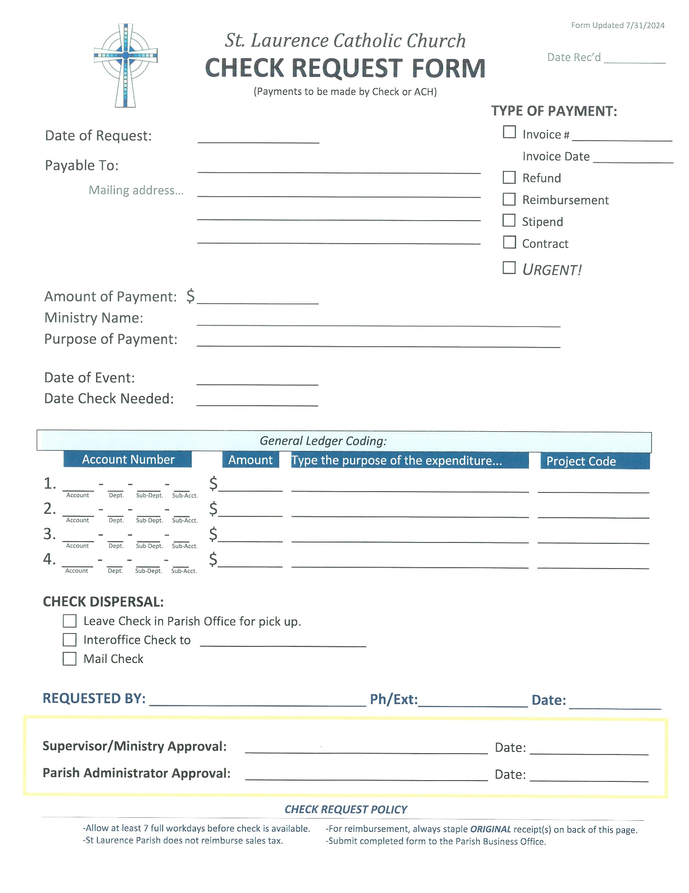

St. Laurence Parish
Form Updated 8/4/2022
Date Rec’d

Deposit Request
SEAL IN ENVELOPE AND
IMMEDIATELY DROP IN BUSINESS OFFICE SAFE.

Date -

Name of Ministry -

Prepared by - Amount of Deposit -

Name Phone number
$ .

Event Name and Date -

Special notes or instructions -
$
Total Deposit
Total Currency…………………………… $

Coins:
x $1.00 = x .50 =
x .25 =
x .10 =
x .05 =
x .01 =
Total Coins………………………………. $
=
=
=
5
2
1
50 =
20 =
10 =
x x x x x
x
Currency (bills):
x $100 =
$
Checks count #
Cash Counting:
Deposited by:
Deposit Date:
Office Use Only

St. Laurence Catholic Church

SAFE ENVIRONMENT

PARISH ADMINISTRATOR: Suzanne Byrne 281-980-9812 sbyrne@stlaurence.org

All volunteers having regular contact with children or youth (any age under 18 years of age) are required to complete CMG Connect training through the Archdiocese of Galveston-Houston.

St. Laurence Catholic Church is committed to providing a safe environment for all our parishioners, especially our children. Therefore, all parish programs abide by the Safe Environment: Protecting God’s Children policies put forth by the U.S. Bishops. All volunteers who have regular, ongoing
interaction with children are obligated to complete CMG Connect training through the Archdiocese of Galveston-Houston.

ACCESS TRAINING SITE: https://www.archgh.org/offices-ministries/office-of-child-and-youth- protection/safe-environment-training-for-adults/

CMG Connect is a web-based platform that assists us to ensure that all employees and volunteers who are in a position of trust with children and vulnerable adults within our schools and parishes are trained to recognize behavior patterns of potential abusers and provide pro-active measures for preventing abuse in any context.

CMG Connect training is completed online, allowing individuals to complete the training at their convenience. It is a 3-part video which provides vignettes of real-life situations to educate the viewer about methods of grooming, desensitization, bullying, and neglect, all of which can lead to abuse.
Each part of the video is immediately followed by a brief questionnaire to further develop understanding. This session takes approximately 1½ hours to complete and does not have to be completed at one sitting.

The Archdiocese of Galveston-Houston Safe Environment compliance training and renewal training is a condition of employment and for volunteer ministry in the Archdiocese of Galveston-Houston.

Education is a key element of the Safe Environment program. All clergy, employees, contracted school personnel, volunteers, members of groups, movements, and organizations over the age of 18, who work, volunteer or participate in any capacity are required to complete the Archdiocesan Safe Environment Training and a criminal background check before they may begin employment, volunteer, or participate with ministries, groups, movements, and organizations. In addition, the mandatory renewal training must be completed every 5 years and a new background check submitted before the 5-year expiration of prior training.

St. Laurence Catholic Church

EMERGENCY PREPAREDNESS

FACILITIES DIRECTOR: Sheila Stulak 281-980-9812 sstulak@stlaurence.org

In the event the parish is faced with an emergency of minor or major proportion affecting the community, please consider the following guidelines for emergency preparedness for your ministry meeting or gathering:

- Begin each meeting in the following way, which honors God and one another, whether attendees are long time parishioners or visitors for the first time:
  - Open with prayer
  - Point out the hospitality features of the room, location of restrooms, water, etc.
  - Note the exit routes, posted in all buildings, and remind attendees that in the event of an emergency/fire alarm, the building must be evacuated.

- Have a means for quickly contacting your members. Flocknote is an effective communication resource; the server for this system is off-site and may be your most efficient method for quickly getting emergency information to your members.

- Encourage your members to be prepared at home. A great resource is https://texasprepares.org/.

- There may be other ways your ministry can play a role in emergency preparedness at the parish level. Please contact Sheila Stulak with your input and offers to help.

